- Paper tries to determine the best exoplanets for atmospheric characterisation.
- Presents two important metrics to give a quantitative prediction for signal to noise ratio for an exoplanet: TSM and ESM (transmission and emission). We just care about TSM.
- Determines a threshold for these metrics as a ‘minimum requirement for strong observability’
- Yields ~300 high quality targets over a large radius size (including larger than Sub-neptunes)
- Paper uses the following bins
1. Terrestrials: Rp < 1.5 R⊕,
2. Small sub-Neptunes: 1.5 < Rp < 2.75 R⊕,
3. Large sub-Neptunes: 2.75 < Rp < 4.0 R⊕,
4. Sub-Jovians: 4.0 < Rp < 10 R⊕.
Transmission Metric:
Estimates the detectability of atmospheric features in transmission.
Scales with:
- Large planet radius
- High equilibrium temperature
- Low surface gravity (low mass)
- Small host star
- Bright host star (J-band magnitude)
A quantity we want to maximise to ensure better data. Due to temperature dependence this will bias towards high temp planets, but we want a range so will need to choose planets with inherently worse TSM values in order to obtain a fair distribution over temp.
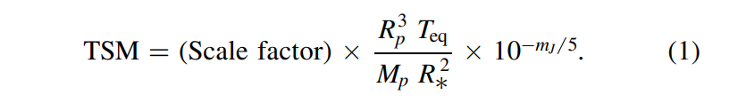
Rp: the radius of the planet in units of Earth radii
Mp: the mass of the planet in units of Earth masses
R*: the radius of the host star in units of solar radii
Teq: the planet’s equilibrium temperature in Kelvin
mJ: the apparent magnitude of the host star in the J band
The “scale factor” is a normalization constant and also is responsible for unit conversion. Determined separately based on planet radius bin.
TSM values that were found range from low (12) to high (178)
- Because no mean molecular weight included in TSM calculation, it was assumed that atmospheric composition was constant for planets in a given radius bin
- A spread in MMW would translate linearly into the TSM, papers implies this effect is more relevant for smaller planets.

Equilibrium temperature: Temp a planet would have if it were in radiative balance with its host star, assuming it reradiates all absorbed stellar energy and has no internal heat sources.
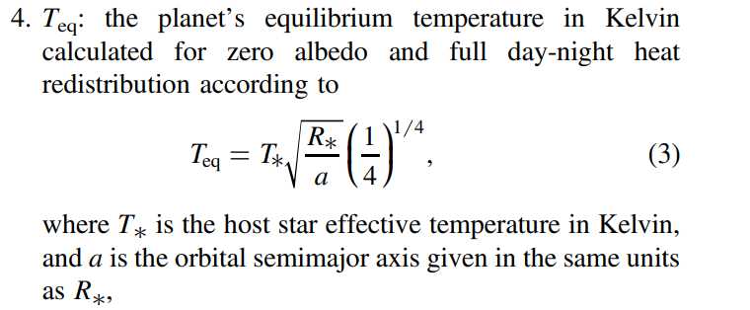
a is semi major axis NOT albedo
The numerator of the fraction ¼ is actually (1-A/4) where A is the albedo which in this case has been assumed as 0. This implies that the planet reflects 0 light. Other sources say 0.3 is a strong approximation for bond albedo

Key quantities for investigation:
Planet Radius
Planet mass
Star Radius
Equilibrium Temperature
Star temperature
Apparent magnitude of host star in J band, a specific range of near-infrared (NIR) wavelengths used in astronomy (centered at approximately 1.25 micrometers).
Atmospheric mean molecular weight (or an assumption for it)

Paper Results
mJ impact: Had an effect on duty cycles (the fraction or percentage of time an astronomical source is active or observable during a specific phenomenon) High is good, low is bad. Could have an impact on how long is needed to observe each exoplanet.
- Small scatter for mJ > 9
- mJ ~ 8.1 required a “bright star readout mode”
- mJ < 9 have lower duty cycles because detector needs to be reset more often
Paper finds that the sub-neptune bins are rich with high S/N exoplanets.
Image below depicts planet size bins with respective recommended cutoffs for acceptable TSM values.
TSM > 90 seems like a good standard for sub neptunes.
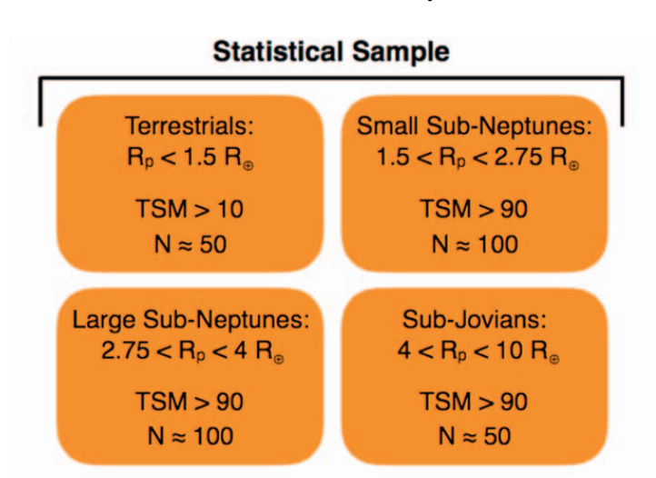
Potential refinement could be done using:
- RV amplitude (radial velocity)
- Stellar activity level
- High false positive likelihood (valid for close orbiting planets)
Quote: “Preliminary results suggest that measuring masses for ∼300 of the best TESS planets for atmospheric characterization would require approximately 400 nights of observing time”

